Develop a delivery plan

# Case study cohort

**CHC53215 Diploma of Alcohol and Other Drugs**

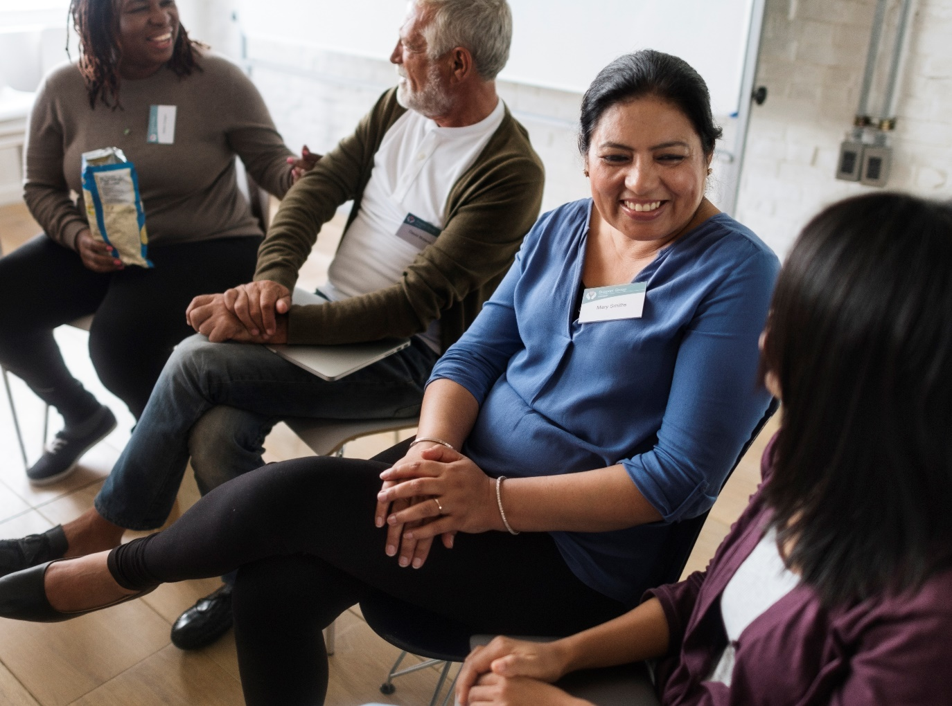

This group is culturally diverse, with mature-aged learners ranging from 25-55. Approximately half of the cohort are domestic students, while the other half are international students, including learners from African, South Asian, and Pacific Islander communities. Many learners have personal or professional connections to substance abuse issues, and a few are Indigenous students passionate about making a difference in their communities. LLN levels vary, with most learners confident in spoken English but some requiring support with academic writing and understanding complex health terminology.

### Images

|  |  |  |  |  |
| --- | --- | --- | --- | --- |
| **Page** | **Description** | **ID/Title** | **Artist** | **Source/**  **License** |
| 1 | People Meeting Seminar Office Concept | People Meeting Seminar Office Concept | Rawpixel | Envato / Rawpixel |