Develop a delivery plan

Case study cohort
CPC32420 Certificate III in Plumbing
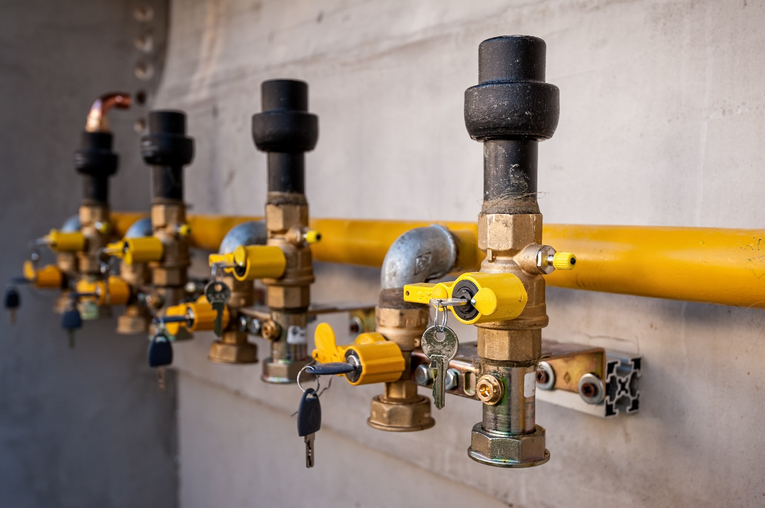The learners are primarily young men and women aged 18-25 who are early in their plumbing apprenticeships. They are physically active and often work long hours, which can leave them feeling fatigued. Most are domestic students, with a few international learners. A small number of students identify as Indigenous Australians, and many live in regional or rural areas where plumbing skills are in high demand. LLN levels vary; some learners excel in practical and visual tasks but struggle with reading technical documents or performing complex calculations. The group is familiar with construction jargon but may need support transitioning to more formal, academic language used in assessments.

Images
Page | Description | ID/Title | Artist | Source/  License
1 | Gas pipe and valve with lock on the wall. | Gas pipe and valve with lock. | scalatore1959 | Envato / scalatore1959

